Kopi Koma Partner Portal: Product Requirements Document

Table of Contents
- Executive Summary
- How to Try the Prototype
- Assumptions
- Client
- Pain points
- Human vs System
- Business Impact
- Success Metrics
- Diagram
- Flowchart
- Stages
- Solution
- Solution Overview
- Functional Requirements
- Feature A: Lead Capture and Auto-Assignment
- Feature B: Pipeline and Approval Status
- Feature C: Stage Processing
- Feature D: AI Fit Score
- Feature E: Quotation and Negotiation
- Feature F: Final Approval
- Feature G: Tasks and Reminders
- Feature H: Target and Sales Performance
- Feature I: Access Control and Audit Trail
- Feature P1 to P3: Partner Portal
- Input, Process, Output
- Mock Ups
- Nonfunctional Requirements
- Scope and Roadmap
- Prototype Limitations
- Use of AI
- References
- Appendix: AI Conversation Screenshots

Executive Summary
Kopi Koma Partner Portal is a web application that digitalizes and centralizes the partnership process between Kopi Koma (fictitious name), a local coffee franchisor, and its candidate franchisees, from the first application until the partnership is approved by both parties. It consists of two connected applications:
- Franchisor Dashboard: used by Sales, Reviewer, Manager, and Super Admin to capture and assign leads, process each pipeline stage, give final approval, and monitor targets.
- Partner Portal: used by candidate franchisees to register, track their application, and respond to quotations.
It addresses three core pain points: leads scattered across WhatsApp and personal spreadsheets, applications stuck with no clear owner or deadline, and quotations approved by chat with no traceable agreement.
For the business, this is a growth tool: Kopi Koma grows by opening outlets through partners, so capturing more leads and losing fewer of them turns directly into more outlets and revenue.
Out of scope: outlet opening and royalty. After approval, the franchise agreement is signed through Privy, and its signing status is tracked on each application.
Prototype (Franchisor Dashboard): https://kopikomapartnerportal.vercel.app
Prototype (Partner Portal): https://kopikomapartnerportal.vercel.app/mitra
Demo password: demo123 (all staff accounts are listed on the login page)

How to Try the Prototype
A 5-minute path through the core flow. Open both links in the same browser so the two apps share data.
- Open the Partner Portal (/mitra), click "Isi data contoh", and submit. The lead is assigned automatically to Rendi (Tangerang region).
- Open the dashboard and log in as Rendi (Sales) from the demo account list. Process the business presentation and the location survey.
- Log in as Bima (Reviewer) and complete the eligibility assessment.
- Log in as Rendi again and send the quotation.
- Back in the Partner Portal, check the status with the application number and email, then agree to the quotation.
- Log in as Laras (Manager), give final approval, and sign the agreement. Open Pipeline, then Completed, to view the signed document.
Extra value (Should have): as Laras, open Target and Performa Sales.

Assumptions

Client
Item | Assumption
Brand | Kopi Koma (fictitious), a local grab-and-go coffee brand with around 80 outlets
Packages | Gerobak (cart): Rp 45 million, no royalty (earns from mandatory raw material supply instead). Cafe: Rp 450 million, 5% monthly royalty
Team | 1 Manager, 4 Sales (2 senior, 2 junior, one region each), 2 Reviewers, 1 Super Admin
Target | 120 new outlets per year (72 Gerobak, 48 Cafe), a stretch target
Revenue | Deal value of approved packages after discount. Royalty is not counted.

Franchising is the main expansion channel for Indonesian F&B: the culinary sector makes up 47.77% of the 311 registered franchisors as of February 2025 [1][2], and chain coffee shops grew from around 1,000 outlets in 2016 to over 2,950 in 2019 [3][4]. For a brand like Kopi Koma, the partnership process is therefore a core business process.

Pain points
# | Pain point | Impact
1 | Leads are scattered and not centralized: they live in each sales' WhatsApp, notes, and spreadsheets. | Leads are forgotten, two sales contact the same candidate, data is lost when a sales leaves.
2 | Candidates do not know their application status. | They keep asking sales, and serious candidates may leave.
3 | Quotations and approvals are negotiated by chat. | No single agreed version, approvals cannot be traced.
4 | No deadline per stage. | Applications get stuck unnoticed.
5 | Screening and location decisions rely on individual judgment. | Inconsistent decisions, outlets in weak locations.
6 | Targets are checked only at month end. | The team finds out too late.
7 | Prospectus delivery and data consent are not recorded. | Legal risk under PP No. 35/2024 [5] and UU PDP No. 27/2022 [6].

Human vs System
Capability | Manual (current) | System | Notes
Capture leads in one place | ⚠️ Limited | ✅ | All leads, from sales or the portal, in one pipeline
Assign leads by region, detect duplicates | ❌ Not available | ✅ | Automatic, with exceptions sent to the Manager
See stage and owner of every application | ⚠️ Limited | ✅ | Pipeline board shows PIC and days waiting
Deadlines and reminders | ❌ Not available | ✅ | Automatic reminders to PIC and Manager when overdue
Record prospectus delivery | ⚠️ Limited | ✅ | Required confirmation with date
Consistent candidate and location assessment | ⚠️ Limited | ✅ | Structured forms and AI fit score with reasons
Quotation versions | ⚠️ Limited | ✅ | Every version kept, revisions need Manager input
Candidate checks status | ❌ Not available | ✅ | 7-step tracker in the portal
Candidate responds to quotation in writing | ⚠️ Limited | ✅ | Agree, request changes, or withdraw in the portal
Trace two-party approval | ⚠️ Limited | ✅ | Approval 1 of 2 (candidate) and 2 of 2 (Manager) logged
Monitor target during the period | ⚠️ Limited | ✅ | Achievement vs target to date, per sales and package
Audit trail and document access log | ❌ Not available | ✅ | Every action and document access logged

Business Impact
Kopi Koma grows by adding partner outlets, and every outlet starts as a lead. The product supports growth through three levers that follow directly from its features:
Lever | How the product drives it | Metric to watch
Capture more leads | The Partner Portal lets candidates apply anytime from Instagram or the website, and every lead from every channel lands in one pipeline | New leads per month by source
Lose fewer leads | Leads are assigned within 1 day, every stage has an owner and a deadline, and stalled applications trigger reminders | Leads assigned within 1 day, overdue stages, lead to approved conversion
Correct course early | Target vs Achievement shows the gap during the period, and the funnel shows how many leads are needed | Achievement vs target to date

Why it matters: at the default conversion of 12%, about 8 leads produce 1 approved outlet. Each additional approved outlet per month at the target package mix (average deal around Rp 207 million) adds about Rp 2.5 billion in deal value per year.

Success Metrics
Metric | Target | Basis
Leads assigned within 1 day | 100% | Deadline of the New lead stage
Time from new lead to final decision | 26 days or less | Sum of stage deadlines
Stages completed on time | 85% or more | Assumption, validate in pilot
Lead to approved conversion | 12% or more | Default funnel rates
Approved outlets per year | 120 | Business target
Approved deal value per year | around Rp 24.8 billion | 6 Gerobak + 4 Cafe per month
Quotation responses via portal | 70% or more | Assumption, validate in pilot

Diagram

Flowchart
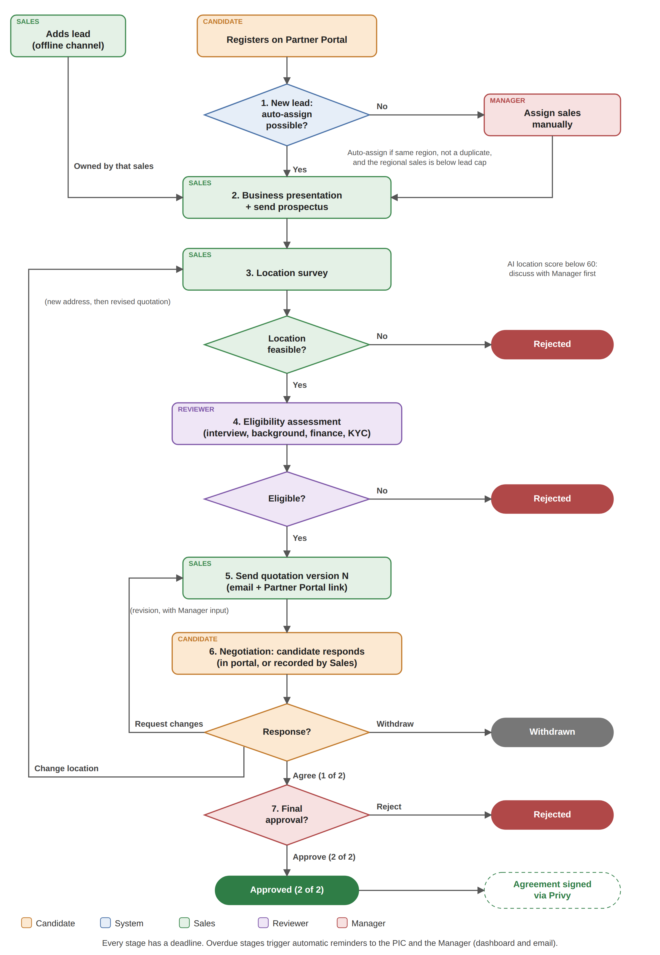

Stages
# | Stage | PIC | Deadline
1 | New lead | System or Manager | 1 day
2 | Business presentation and prospectus | Sales | 4 days
3 | Location survey | Sales | 5 days
4 | Eligibility assessment | Reviewer | 4 days
5 | Quotation | Sales | 3 days
6 | Negotiation | Sales | 7 days
7 | Final approval | Manager | 2 days

Solution

Solution Overview
The system covers 12 features across two applications:
# | App | Feature | Problem | Key question the user can answer
A | Franchisor Dashboard | Lead Capture and Auto-Assignment | 1 | "Is every new lead owned by the right sales?"
B | Franchisor Dashboard | Pipeline and Approval Status | 1, 4 | "Where is each application, and who is it waiting for?"
C | Franchisor Dashboard | Stage Processing | 5, 7 | "Has this candidate passed each check?"
D | Franchisor Dashboard | AI Fit Score | 5 | "How well does this candidate fit, and why?"
E | Franchisor Dashboard | Quotation and Negotiation | 3 | "What is the latest offer, and how did the candidate respond?"
F | Franchisor Dashboard | Final Approval | 3 | "Have both parties approved?"
G | Franchisor Dashboard | Tasks and Reminders | 4 | "What do I need to do today?"
H | Franchisor Dashboard | Target and Sales Performance | 6 | "Are we on pace, and who needs help?"
I | Franchisor Dashboard | Access Control and Audit Trail | 7 | "Who did what, and who saw this data?"
P1 | Partner Portal (Franchisee) | Registration | 1 | "How do I apply?"
P2 | Partner Portal (Franchisee) | Status Tracker | 2 | "Where is my application?"
P3 | Partner Portal (Franchisee) | Quotation Response | 3 | "How do I accept or change the offer?"

Functional Requirements

Feature A: Lead Capture and Auto-Assignment
ID | User Story | Requirement | Acceptance Criteria
FR-A-001 | As a Sales, I want to add offline leads so that every candidate is recorded. | Form: name, phone, email, city, package, capital, source of funds, management plan, lead source, location, documents, and required data consent. | Cannot save without consent and required fields. Lead goes to Business presentation under that sales.
FR-A-002 | As a Manager, I want portal leads assigned automatically so that none wait for me. | Assign by city to the regional sales. Send to the Manager queue if the city is outside all regions, phone or email matches an active lead, or the sales is at the active lead cap (senior 15, junior 10). | Exceptions show "No sales yet" with the reason. Who assigned the lead and when is recorded.

Feature B: Pipeline and Approval Status
ID | User Story | Requirement | Acceptance Criteria
FR-B-001 | As a Manager, I want all active applications by stage so that I can spot bottlenecks. | Kanban of 7 stages with package filter and search. Completed tab (approved, rejected, withdrawn) with filters. | Card shows name, city, package, AI score, PIC, days in stage. Sales see only their own leads. Overdue indicators: Manager and Super Admin only.
FR-B-002 | As an internal user, I want an approval timeline so that I can see where an application is. | 7-step timeline with PIC, date, and waiting time. | Opens from the detail and Tasks. Current step shows PIC and days waiting.

Feature C: Stage Processing
ID | User Story | Requirement | Acceptance Criteria
FR-C-001 | As a Sales, I want to record the presentation so that prospectus delivery is provable. | Date, mode, notes, required prospectus confirmation. | Cannot complete without confirmation. Date is stored (PP No. 35/2024 requires delivery 14 days before signing [5]).
FR-C-002 | As a Sales, I want to record the location survey so that location is decided early. | Rating, foot traffic, notes, feasible or not. SOP reminder to consult the Manager if the AI location score is below 60. | Not feasible: Rejected. Feasible: Eligibility assessment, or a revised quotation after a location change.
FR-C-003 | As a Reviewer, I want a checklist so that every candidate is assessed the same way. | Interview, background check, financial verification, KYC, commitment, pass or fail with reason. | Fail: Rejected with reason. Pass: Quotation.

Feature D: AI Fit Score
ID | User Story | Requirement | Acceptance Criteria
FR-D-001 | As a Reviewer or Manager, I want a fit score with reasons so that screening is consistent. | Score 0 to 100: profile 40% (capital, funds, experience, management, documents), location 60% (crowd, competitors, nearest outlet, location type, survey). | Score and reasons shown on card and detail. Never rejects or moves a stage automatically.

Feature E: Quotation and Negotiation
ID | User Story | Requirement | Acceptance Criteria
FR-E-001 | As a Sales, I want versioned quotations so that there is one agreed offer. | Package, discount, payment terms, opening date. Each send creates version N, emailed with a portal link. Revisions require "Result of discussion with Manager". | All versions kept. Revision cannot be sent without the field.
FR-E-002 | As a Sales, I want to record a phone or in-person response so that it is not lost. | Agree, request changes, or withdraw on behalf of the candidate. | Changes: back to Quotation. Location change: new address required, back to Location survey. Withdraw: closed.

Feature F: Final Approval
ID | User Story | Requirement | Acceptance Criteria
FR-F-001 | As a Manager, I want to approve or reject so that the partnership is confirmed by both parties. | Approve or reject (reason required). No location revision. | Approve: 2 of 2, revenue counted, agreement sent through Privy. Candidate sees the result in the tracker.
FR-F-002 | As a Manager, I want to see whether each agreement is signed so that I know which closed deals are complete. | Signing status per party (candidate and Kopi Koma) updated from Privy. The Manager signs for Kopi Koma from the application detail. | Completed table shows "Not signed", "Waiting for candidate or Kopi Koma", or "Signed", with a "View document" link to the signed agreement (parties, agreed quotation, approval trail, and both e-signatures with timestamps), downloadable as PDF. Each signature and each document view is logged. Sales is notified when both have signed.

Feature G: Tasks and Reminders
ID | User Story | Requirement | Acceptance Criteria
FR-G-001 | As an internal user, I want my pending actions in one list so that I know what to do. | Tasks per user. Manager filters: My tasks, All, Sales, Reviewer. | Row shows candidate, action, PIC, waiting time, deadline status.
FR-G-002 | As a Manager, I want overdue stages to trigger reminders so that follow-up is automatic. | When days in stage exceed the deadline, notify PIC and Manager by dashboard and email. No manual button. | Item shows "Overdue N days" and "Reminder sent".

Feature H: Target and Sales Performance
ID | User Story | Requirement | Acceptance Criteria
FR-H-001 | As a Sales or Manager, I want achievement vs target during the period so that we can act early. | Monthly, quarterly, semester, yearly. Gerobak, Cafe, revenue: target, gap, target to date, pipeline opportunities. Funnel from adjustable conversion rates. | Monthly target: senior 2 Gerobak + 1 Cafe, junior 1 + 1. Days 1 to 9 show "Early period".
FR-H-002 | As a Manager, I want to compare sales so that I know who needs help. | Table per sales: Gerobak, Cafe, revenue vs target, status from the weakest metric. | Sorted best to weakest. Opens the sales' profile.

Feature I: Access Control and Audit Trail
ID | User Story | Requirement | Acceptance Criteria
FR-I-001 | As a Super Admin, I want access by role so that users see only what they need. | RBAC per the matrix below. | Sales cannot open other sales' leads. Super Admin actions are logged under their name.
FR-I-002 | As a Manager, I want every action logged so that data access is accountable. | Log status changes, quotation versions, approvals, document access, and portal actions with actor and time. | Visible in the History tab. Portal actions show "Candidate (partner portal)". Not editable.

Permission | Super Admin | Manager | Sales | Reviewer | Candidate
View pipeline | All | All | Own | All | Own (number + email/phone)
Add lead | Yes | No | Yes | No | Self-register
Assign unassigned lead | Yes | Yes | No | No | No
Presentation, survey, quotation, negotiation | Yes | No | Own | No | Respond to quotation
Eligibility assessment | Yes | No | No | Yes | No
Final approval | Yes | Yes | No | No | No
View candidate documents | Yes | Yes | Own | Yes | Own
View signed agreement (Privy) | Yes | Yes | Own | No | Own
Overdue indicators, Sales Performance | Yes | Yes | No | No | No
Target | Team | Team | Own | No | No

Reviewers cannot view the signed agreement: their work ends at the eligibility assessment, and the agreement contains personal and commercial data they do not need.

Feature P1 to P3: Partner Portal
ID | User Story | Requirement | Acceptance Criteria
FR-P1-001 | As a candidate, I want to register online so that I can apply anytime. | Form with package, capital, location, and required data consent. | Application number shown. Lead follows FR-A-002.
FR-P1-002 | As a candidate, I want answers to common questions so that I can decide before registering. | FAQ on the registration page: packages, costs, royalty, timeline, location, documents, payment, data privacy, and signing. | Questions expand on click. A "Lihat FAQ" link at the top jumps to the section.
FR-P2-001 | As a candidate, I want to check my status so that I do not need to ask. | Lookup by application number plus email or phone. 7-step tracker with the sales' contact. | Wrong combination shows an error without revealing data.
FR-P3-001 | As a candidate, I want to respond to the quotation directly so that my answer is recorded. | Agree (requires ticking "I have read and agree to quotation version N"), request changes (new address for a location change), or withdraw. | Agree logs approval 1 of 2. After final approval, the candidate can sign the agreement through Privy from the tracker.

Input, Process, Output
Stage | Input | Process | Output
1. New lead | Candidate data, location, consent | Duplicate, region, and capacity check; AI score | Application number, assigned sales or Manager queue
2. Presentation | Date, mode, prospectus confirmation | Sales presents and sends the prospectus | Prospectus date stored, to Survey
3. Location survey | Address, rating, traffic, AI location score | Sales assesses (with Manager if score below 60) | Feasible: Assessment. Not: Rejected
4. Eligibility assessment | Interview, background, bank statement, ID, commitment | Reviewer completes the checklist | Eligible: Quotation. Not: Rejected
5. Quotation | Package, discount, terms, opening date | System creates and emails version N | Quotation version N recorded
6. Negotiation | Candidate response (portal or via sales) | System routes by response | Agree: Final approval. Changes: Quotation or Survey. Withdraw: closed
7. Final approval | History and agreed quotation | Manager decides | Approved (revenue counted) or Rejected

Mock Ups
Try the clickable prototype: Franchisor Dashboard https://kopikomapartnerportal.vercel.app (password demo123) and Partner Portal https://kopikomapartnerportal.vercel.app/mitra
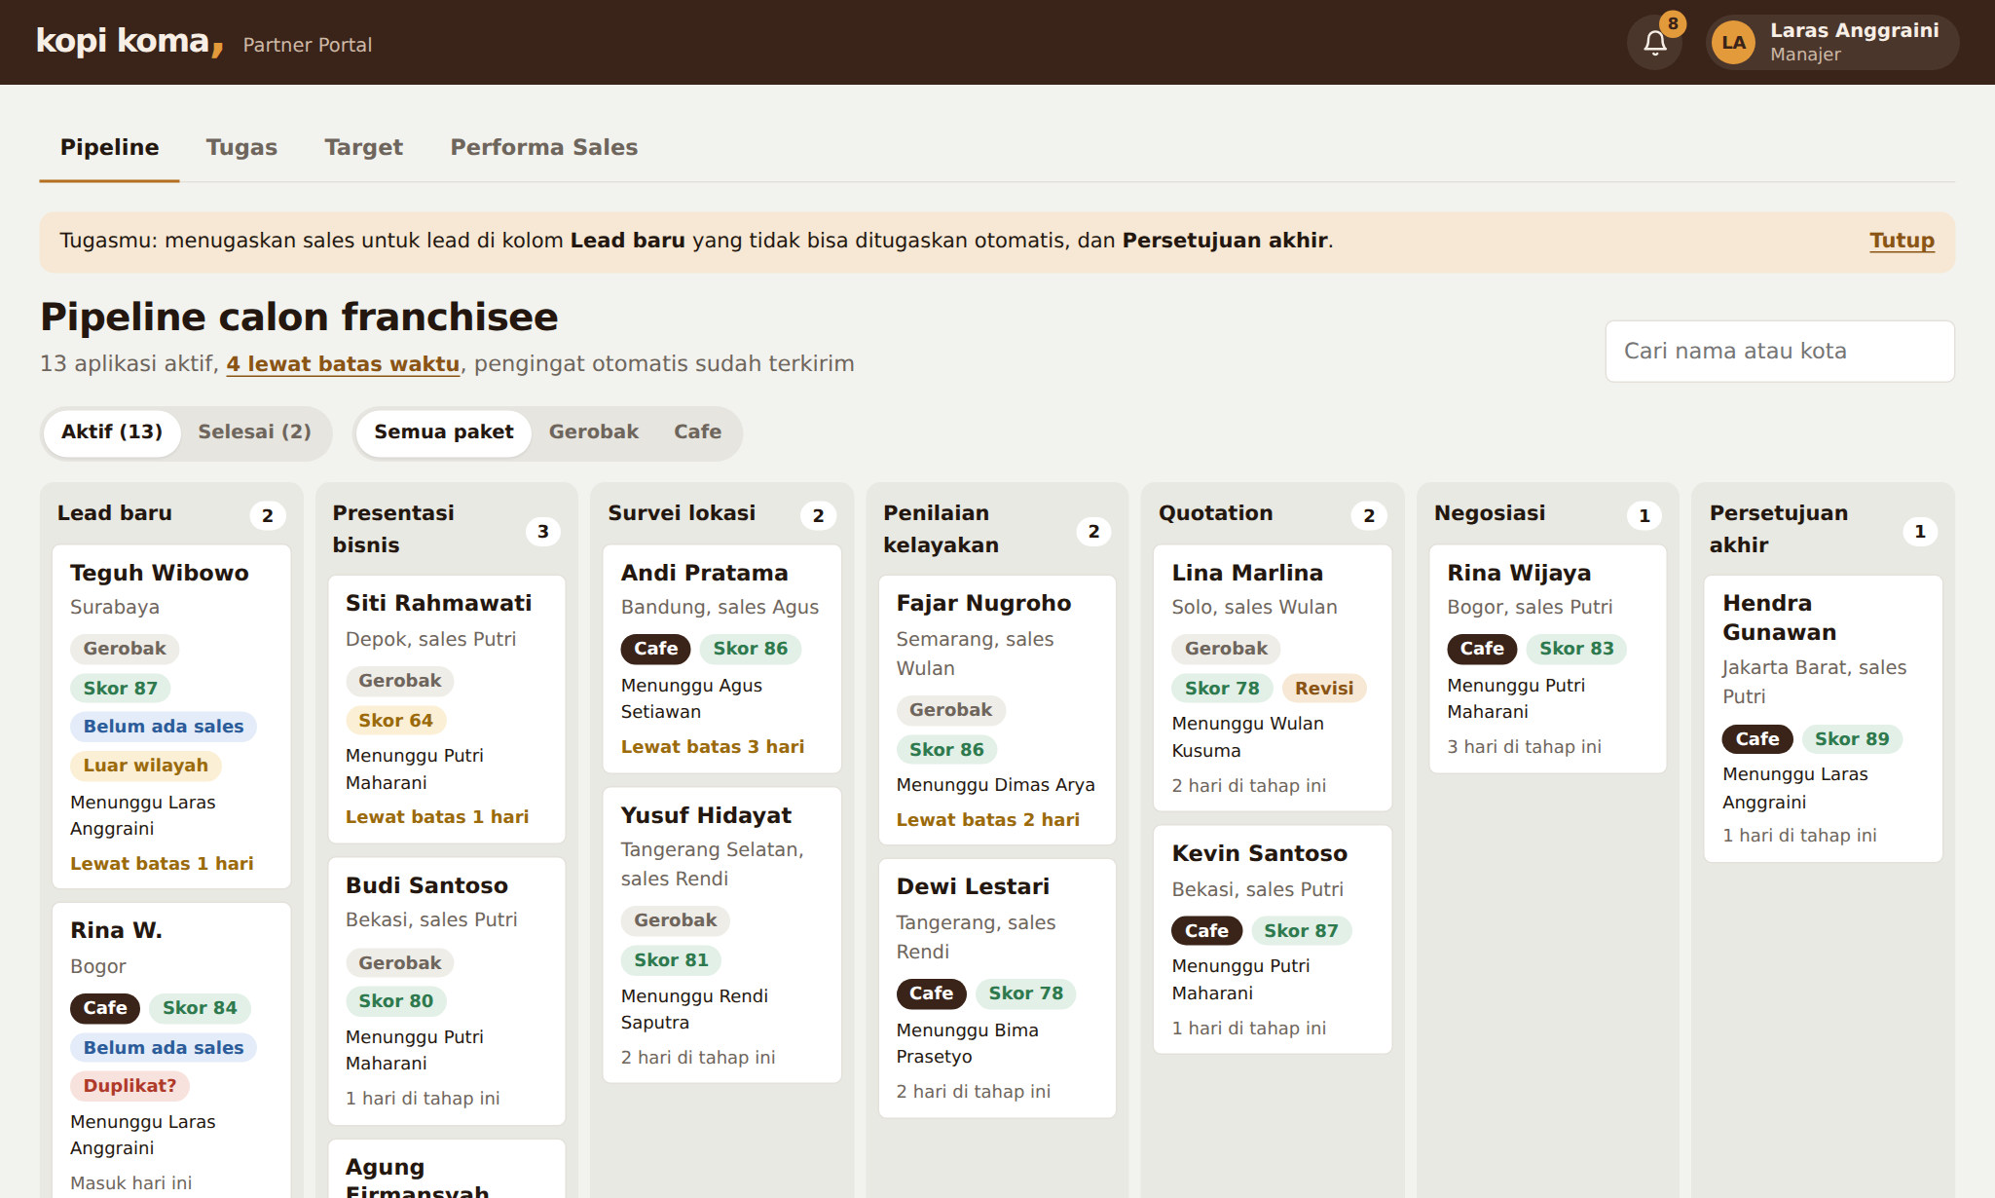 | 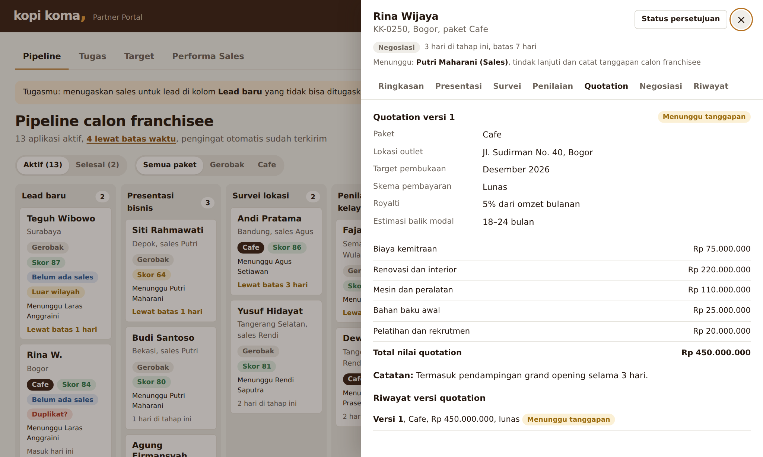
Pipeline (Manager) | Application detail: quotation

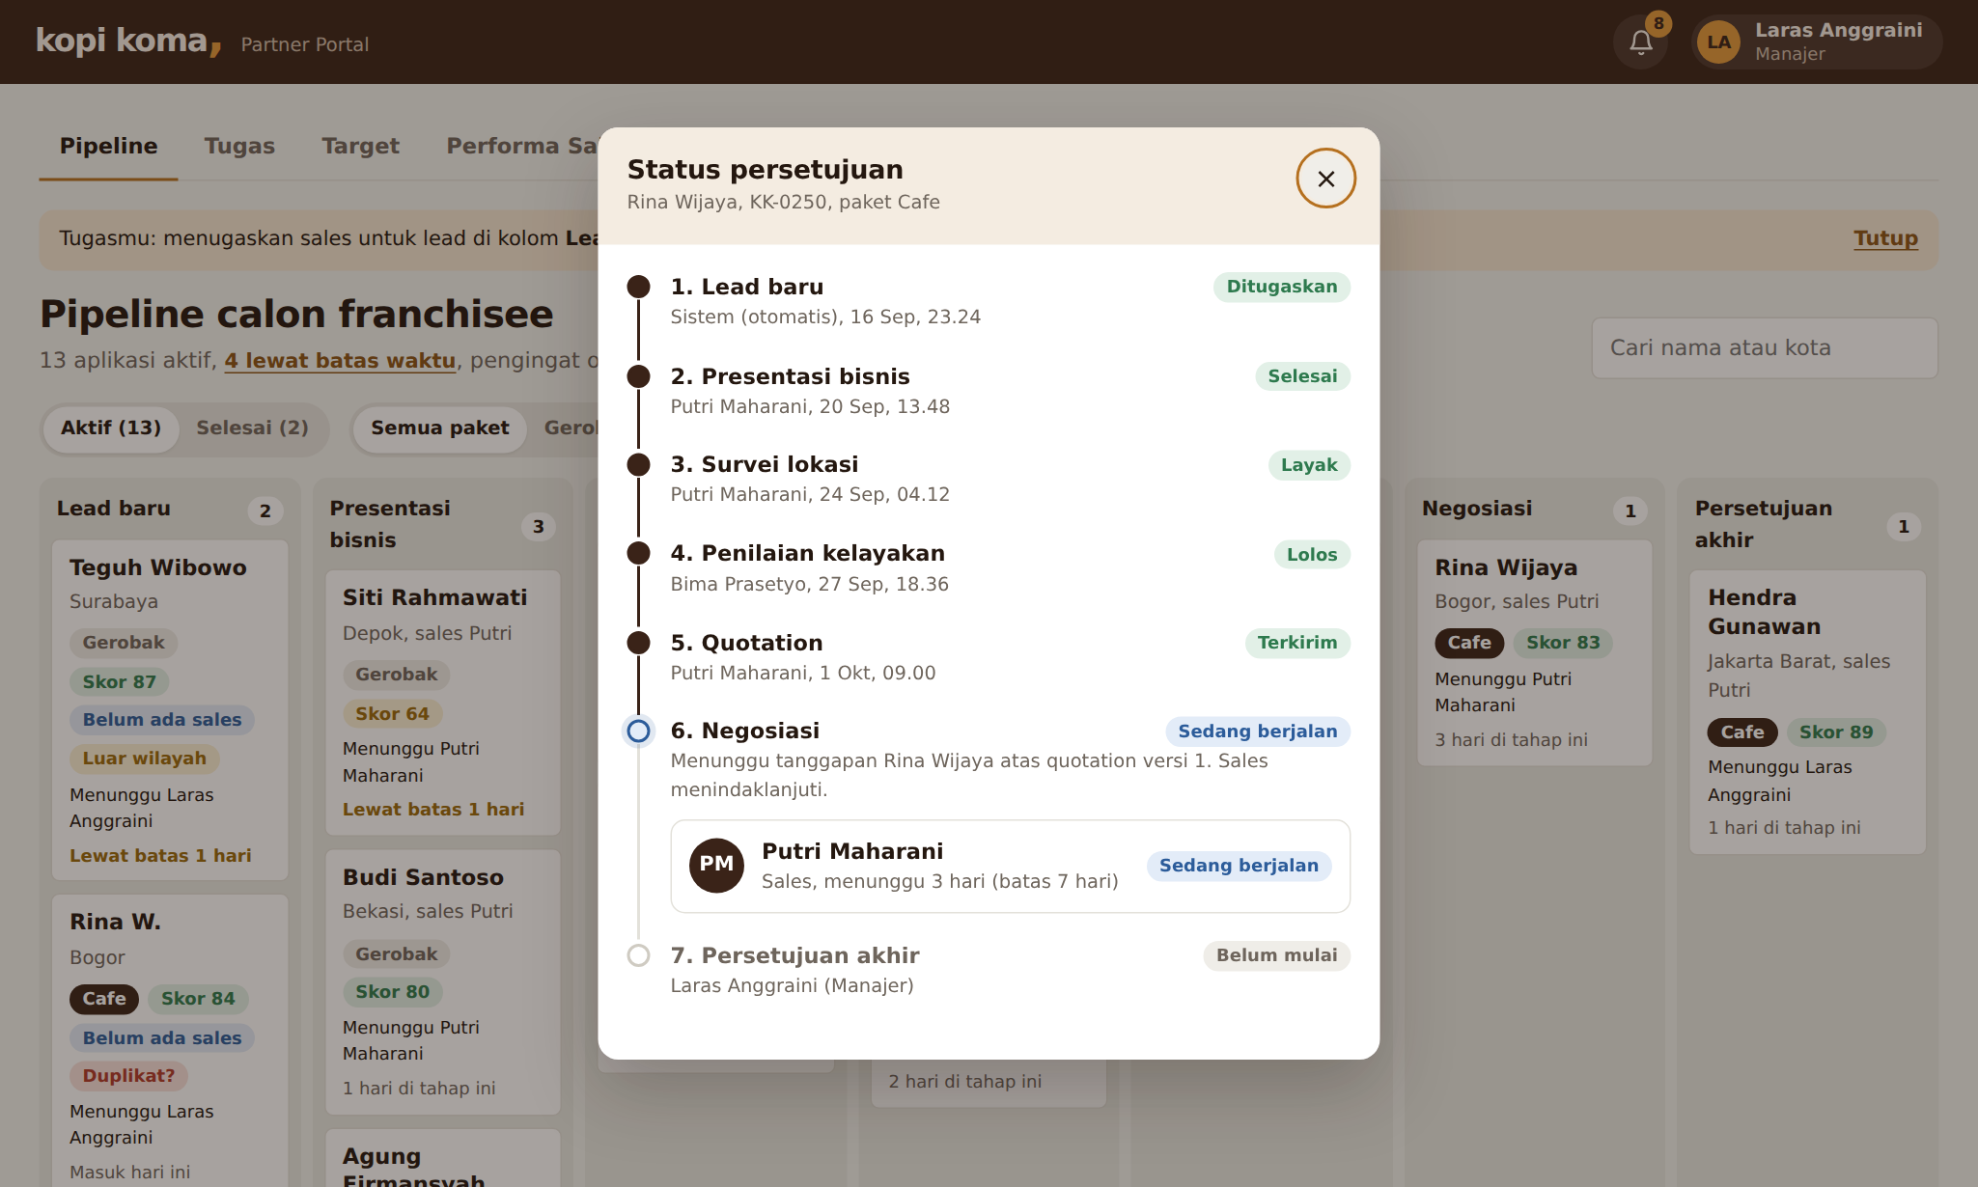 | 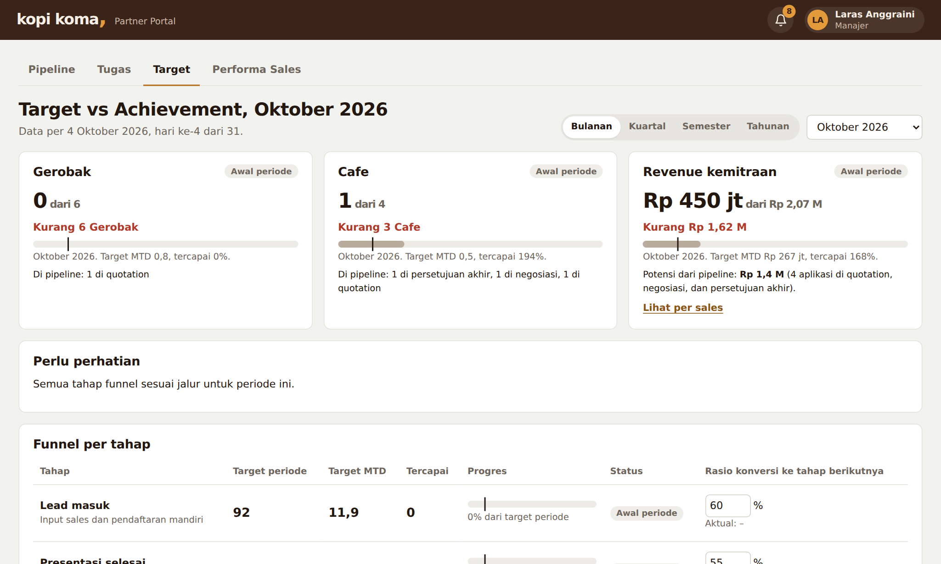
Approval status | Target vs Achievement

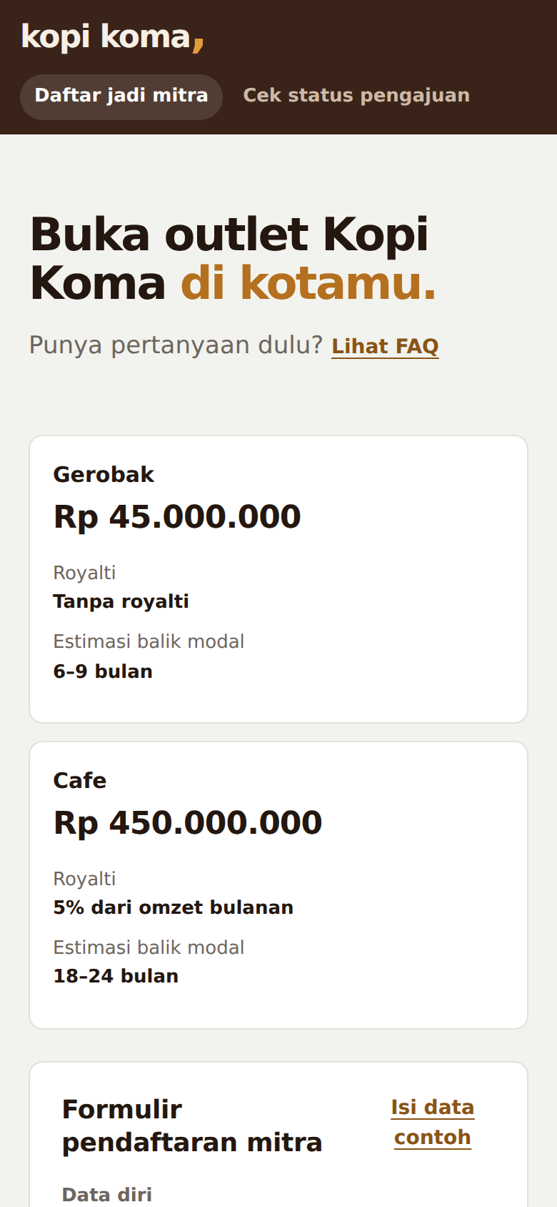 | 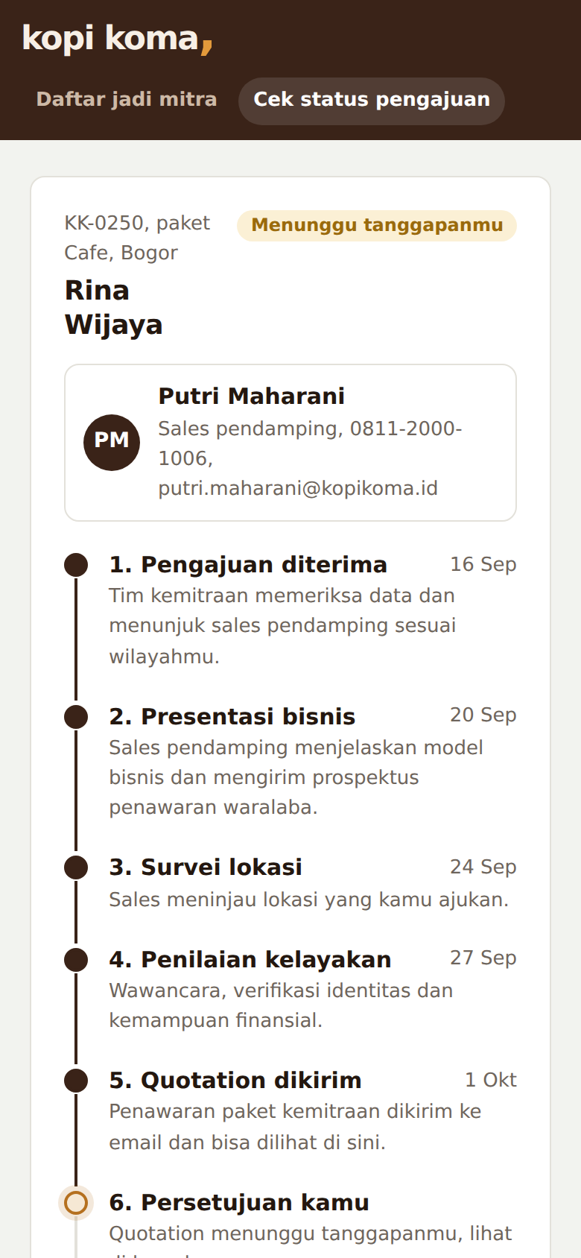 | 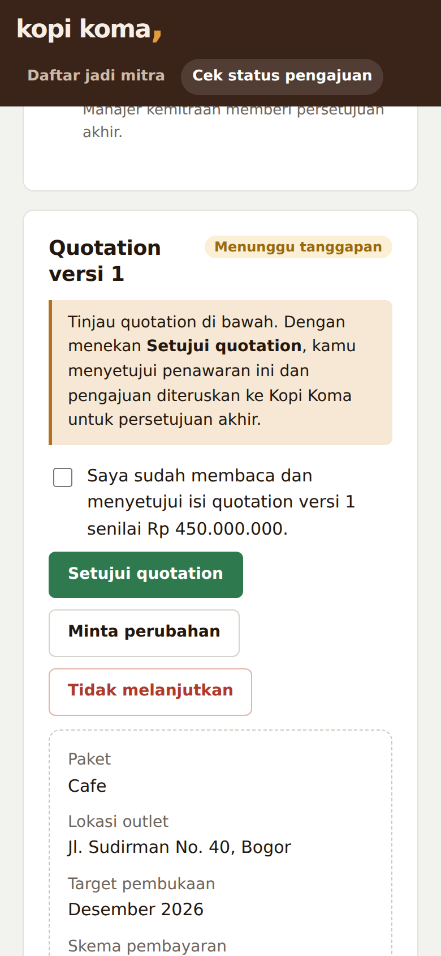
Portal: registration | Portal: tracker | Portal: quotation response

Nonfunctional Requirements
Area | Requirement
Privacy (UU PDP) [6] | Consent before saving a lead, access by role, document access logged, rejected candidates' data deleted after a retention period
Auditability | All actions logged with actor and time, not editable
Responsible AI | Fit score shows reasons, never decides automatically, reviewed against outlet performance for bias
Mobile | Portal is mobile first. Dashboard is laptop first, usable on phones
Performance | 99.5% availability in working hours, pages load under 3 seconds on 4G
Language | Bahasa Indonesia UI, keeping terms like Sales, Lead, Quotation, Pipeline

Scope and Roadmap
Priority | Scope | Phase
Must have | A, B, C, E, F, G, I, P1, P2, P3 | MVP (months 0 to 3), pilot in one region
Should have | D (AI fit score), H (targets) | MVP if time allows
Could have | Live Privy API integration, WhatsApp notifications, real map data, KYC document verification | Phase 2 (months 3 to 6)
Won't have (now) | Royalty tracking, outlet operations, payment gateway | Phase 3 or later

Open question for the client: should large discounts need Manager approval before a quotation is sent?

Prototype Limitations
- Data is stored in the browser, so the dashboard and portal connect only within the same browser. "Reset demo data" restores the sample data.
- The login page lists demo accounts. Production would use company login (SSO).
- The AI fit score uses rule-based weighting and simulated map data.
- Emails are simulated as dashboard notifications. Privy signing is simulated: the sign buttons stand in for the Privy signing page and status update.

Use of AI
I used Claude (Anthropic) throughout the project. The product decisions were mine, and I checked its output before using it.
Activity | AI did | I did
Pain points, features, and flow | Tidied up my pain points, feature list, and funnel into a clear structure | Defined the pain points, features, and funnel, designed the business process (stages, PIC, deadlines, and approval rules), and pointed out the special cases the flow must handle (for example, duplicate leads, leads outside any sales region, and location changes during negotiation)
Prototype | Built the HTML prototype, first in Claude chat and then in Claude Code, over many feedback rounds | Reviewed each version and decided layout, wording, and terminology
Testing | Ran automated browser tests on every role and screen size | Defined what "correct" means and checked results
Development and deployment | Set up the GitHub repository, pushed every revision, and guided the Vercel deployment so the live prototype updates automatically on each push | Created the Vercel project, connected it to GitHub, and checked each deployed version

Lesson: AI is fast at producing options and code, but can sound confident about inaccurate data, so every source had to be checked.

References
- ANTARA News, "Kemendag sebut sektor kuliner masih mendominasi bisnis waralaba". https://www.antaranews.com/berita/4774885/kemendag-sebut-sektor-kuliner-masih-mendominasi-bisnis-waralaba
- Tempo, "Mendag: Waralaba Serap 97 Ribu Tenaga Kerja dengan Omzet Rp 143 Triliun". https://www.tempo.co/ekonomi/mendag-waralaba-serap-97-ribu-tenaga-kerja-dengan-omzet-rp-143-triliun-1218788
- Marketeers, "Toffin: Nilai Pasar Kedai Kopi di Indonesia Capai Rp 4,8 Triliun". https://www.marketeers.com/toffin-nilai-pasar-kedai-kopi-di-indonesia-capai-rp-4-8-triliun/
- Warta Ekonomi, "Bisnis Kedai Kopi di Indonesia Cerah, Jumlahnya Melesat 3X Lipat". https://wartaekonomi.co.id/read262062/bisnis-kedai-kopi-di-indonesia-cerah-jumlahnya-melesat-3x-lipat
- JDIH BPK, PP No. 35 Tahun 2024 tentang Waralaba. https://peraturan.bpk.go.id/Details/297489/pp-no-35-tahun-2024
- JDIH BPK, UU No. 27 Tahun 2022 tentang Pelindungan Data Pribadi. https://peraturan.bpk.go.id/Details/229798/uu-no-27-tahun-2022

Appendix: AI Conversation Screenshots
The AI conversation log is attached as a separate PDF.

